Bahria University,

Karachi Campus



LAB EXPERIMENT NO.

12

LIST OF TASKS

|  |  |
| --- | --- |
| TASK NO | OBJECTIVE |
| 1 | **Train the Artificial Neural Network using the dataset provided in the lab.** |
| 2 | **Train the Artificial Neural Network using the iris dataset and discussed the results.** |

**Task 1: Train the Artificial Neural Network using the dataset provided in the lab.**

**Solution:**

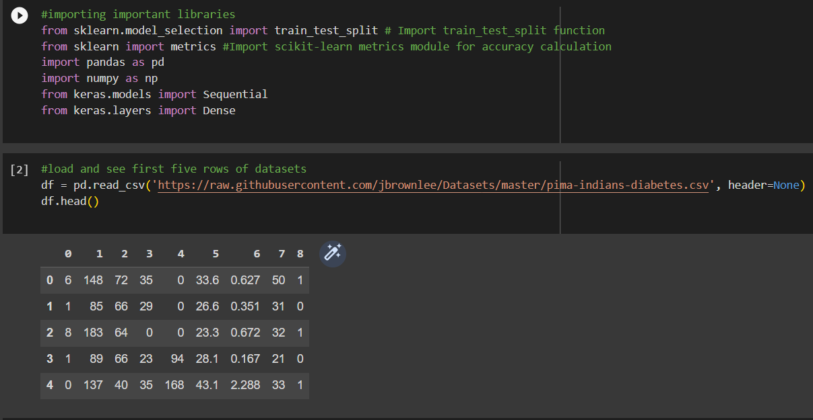

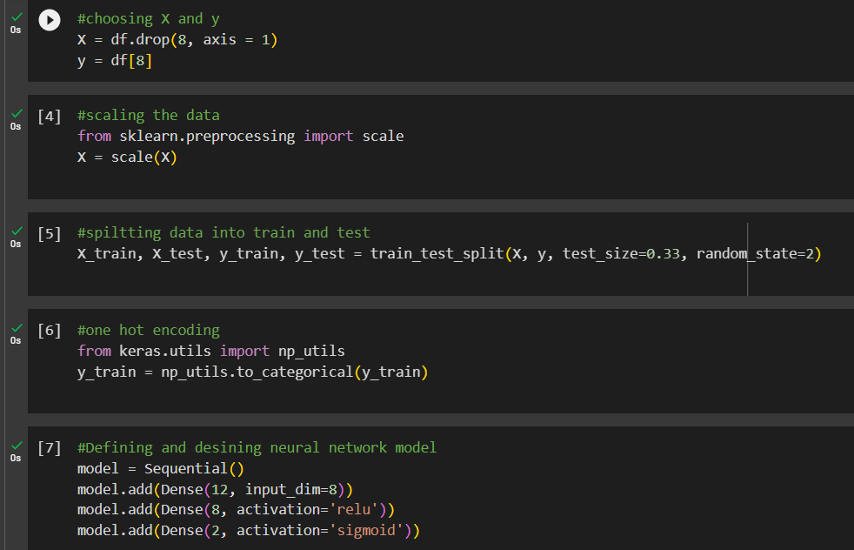

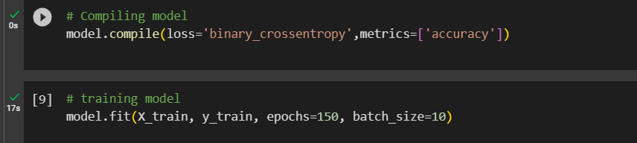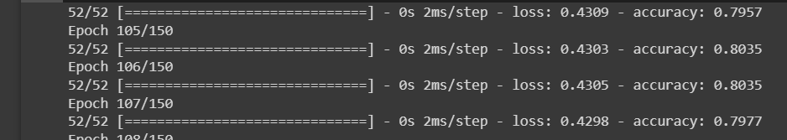

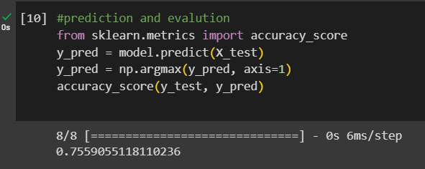

# **Task 2: Train the Artificial Neural Network using the iris dataset and discuss the results.**

**Solution**

from sklearn.datasets import load_iris

from sklearn.model_selection import train_test_split

from sklearn.preprocessing import StandardScaler

from sklearn.neural_network import MLPClassifier

from sklearn.metrics import accuracy_score

# Load the iris dataset

iris = load_iris()

X = iris.data

y = iris.target

# Split the data into training and testing sets

X_train, X_test, y_train, y_test = train_test_split(X, y, test_size=0.2, random_state=42)

# Normalize the feature values

scaler = StandardScaler()

X_train = scaler.fit_transform(X_train)

X_test = scaler.transform(X_test)

# Train the ANN

model = MLPClassifier(hidden_layer_sizes=(10, 10), max_iter=1000, random_state=42)

model.fit(X_train, y_train)

# Make predictions on the test set

y_pred = model.predict(X_test)

# Calculate accuracy

accuracy = accuracy_score(y_test, y_pred)

print("Accuracy:", accuracy)

An accuracy score of 0.9667 suggests that the trained neural network successfully classified the iris flowers with a 96.67% accuracy rate. This high accuracy indicates that the model has effectively learned the data patterns and can make accurate predictions. It is a desirable outcome, especially considering the small and well-structured nature of the iris dataset.